* Introduction (à faire en dernier)
* Réalité virtuelle, Réalité augmenté et Metaverse
  + Réalité virtuelle
  + Réalité augmentée
  + Metaverse
* Technologie haptique
  + Origine & Definition
  + Différentes technologies haptiques
    - Touch-based Haptic Interfaces
    - Skin-attachable Haptic Interfaces
    - Neuro-haptic Interface
  + Avenir de l’haptique
* Ethique Metaverse
  + L’haptique & le social

# Augmented Reality, Virtual Reality, and Metaverse

## Augmented Reality

According to the booklet, “The-Concise-FINTECH-COMPENDIUM” by Patrick Schueffel, p.2: “Augmented reality is an enhanced version of the physical, real-world reality of which elements are superimposed by computer-generated or extracted real-world sensory input such as sound, video, graphics, or haptics.”. So, Augmented reality (AR) simulates an additional sensory to the user while that user is getting its normal sensory input from its surroundings.

AR requires a device with a camera and AR software, such as a smartphone, tablet, or smart glasses, to overlay digital material in a real-world environment. To process the video stream captured by the camera and distinguish objects in the environment, the AR software use computer vision. Computer vision is a branch of artificial intelligence (AI) that allows computers and systems to extract useful information from digital images, videos, and other visual inputs, as well as to conduct actions or make recommendations based on that data. This enables the AR system to project virtual content in a precise place. The digital content is then realistically shown on top of the real environment via the display device.

Two main types of AR exist marker-based AR and marker-based AR. Marker-based AR applications use physical images captured by the camera to place digital content on top of them. Logos, posters, and QR codes are different types of markers. Markerless AR works without markers and allows users to choose where the digital content is displayed. To obtain information about the environment, Marker-based AR applications use the device's camera, GPS, compass, and accelerometer. Markerless AR uses three different methods: Superimposition-based AR, Projection-based AR, and Location-based AR. Superimposition-based AR recognizes items in the actual world and partially or completely replaces their original perspective. Location-based AR works in specific places. The virtual object is positioned at the point of interest using the device's GPS and compass. Unlike the previous methods, projection-based AR does not require a display device to display virtual objects but instead projects light onto a surface to do so.

## Virtual Reality

Virtual Reality (VR) uses computer technology to build three-dimensional artificial environments that people can interact with. VR technology allows users to be immersed in virtual experiences rather than flat-screen digital experiences using special equipment such as headsets. Unlike AR which adds virtual objects to the real world, VR provides a more immersive experience and completely simulates an environment.

Virtual reality technologies deceive the human brain into viewing the virtual environment as reality by replicating as many senses as possible. Special hardware components are used to achieve this. The main component is head-mounted displays (HMD). HMDs are used on headsets and provide a three-dimensional picture of the virtual environment. It simulates human eyesight with a field of view and frame rate. Another important component is headphones. Headphones provide realistic audio of the environment that matches what the user sees from HMD. To track and adjust the virtual environment, gyroscopes, accelerometers, and magnetometers are used. They look at the position and the direction of the user’s head in the room to transcripts them in the simulation. Users can interact with the virtual world using controllers, gloves, treadmills, etc, and can stimulate other senses such as touch.

The experience of VR can be fully or semi-immersive. A fully immersive VR is the experience that gives the most lifelike experience. It involves all the components used for simulating a sensation, the user is completely cut off from the rest of the real world. The main difference with the semi-immersive VR experience is that the user is not completely isolated from reality and remains connected to their physical surroundings.

## Metaverse

The term "metaverse" first appeared in 1992 in the novel "The Virtual Samurai", written by Neal Stephenson. The world described there is a science fiction universe, which could be close to our future reality. The article “Metaverse” by Stylianos Mystakidis gives the following definition: “The Metaverse is the post-reality universe, a perpetual and persistent multiuser environment merging physical reality with digital virtuality. It is based on the convergence of technologies that enable multisensory interactions with virtual environments, digital objects and people such as virtual reality (VR) and augmented reality (AR).” However, since multiple brands have their metaverse, there is not one metaverse but multiple metaverses. So, the definition is the same but must be more general a speak about “a metaverse” and not “the Metaverse”.

REF (ONLY ARTICLE OR BOOK):

The-Concise-FINTECH-COMPENDIUM: <https://web.archive.org/web/20180425130029/http://www.heg-fr.ch/FR/HEG-FR/Communication-et-evenements/evenements/Documents/Schueffel2017_The-Concise-FINTECH-COMPENDIUM.PDF>

Metaverse: <https://www.mdpi.com/2673-8392/2/1/31/htm>

# Ethics in the Metaverse

Advances in virtual reality technology allow for a more immersive, realistic, and better experience of the metaverse. The metaverse uses data collected in the real world to offer immersive experiences. This virtual universe that this new technology offers, gives the possibility to be in a world that is closer and closer to the real world. With the appearance of haptic technology, users can interact with other assets and virtual avatars. A haptic virtual reality suite allows users to feel physical contact sensations all over their body while he immerses themselves in virtual reality. However, the relationship and social interactions can be valuable in inferring users' habits, activities, and choices in the metaverse.

The reality devices that the metaverse incorporates can therefore capture a large amount of information, from users' biometric data to spatial data, including environments such as the physical space of ultimate. It goes without saying that a real ethical problem arises.

The approach of recent activities conducted on the ethical issue of the metaverse reveals concerns related to the vulnerability of certain groups of people, the interaction between users, the aftereffects of the consumption of haptic technology, the confusion between real and virtual, data issues, the metaverse as an interface to inflict physical harm, and the potential psychological and social implications.

Indeed, the framework and level of freedom are not yet clearly defined, so privacy is at risk. The metaverse can collect certain biometric data and the various movements made, preferences, places visited ... that are not obvious to users. The collected biometric data endangers the most personal aspects of our existence.

Moreover, as we have noted earlier, liver technology allows sensory feedback. This poses a huge ethical problem because any virtual contact is reflected in the physical body. Indeed, the sensors attached to the users can realistically control their avatar. The metaverse cannot control the psychological state of the users, so the users are not safe from virtual aggressions on the avatars, which reverberate on the physical body.

The development of more and more realistic virtual worlds with the concept of the metaverse allows us to use the advances of the technology including the sensory return with the haptic technology. This technology poses an ethical problem essentially based on privacy. This technology collects biometric data to make the user's experience in the metaverse more realistic.

In general, the metaverse poses an ethical problem in the management of personal data.

The increase of realism by the metaverse technology can be accompanied by an increase in personal data acquisition by the haptic technology. To better fluidify the movements of the avatars, to activate all the useful functionalities for the geographical location in which we are. Traits, including motor actions to move and make certain movements, eye movement patterns, and reflexes, as well as information about preferences, habits, and interests, can be recorded (Spiegel).

This kind of personal data cannot normally be collected by current products or experiences without this technology integrated into our current consumption habits. Thus, it will require new thinking and consideration to address data collection specific to haptic technology.

3D Virtual worlds and the metaverse: Current status and future possibilities: <https://dl.acm.org/doi/abs/10.1145/2480741.2480751>

## Inertial Actuator

### Piezoelectric Actuator

Another vibration technology is the piezoelectric actuator. The elementary principle for piezoelectric actuators is the inverse piezoelectric effect. It can produce deformation (mechanical stress) when an AC electric field to a piezoelectric material is applied. This deformation is proportional to the intensity of the electric field. Polymers are commonly employed in piezoelectric-based force touch-sensing devices due to their excellent mechanical characteristics. However, ceramics are commonly used in haptic applications due to their high piezoelectric coefficient. To transmit the force created by the inverse piezoelectric effect, one side of the piezoelectric material is attached to the mass block. To keep the system stable, the other side is joined to the fixed base plate. The haptic feedback can be achieved by using a high voltage (200 V).

|  |  |
| --- | --- |
| a) | b) |

Figure 1: Piezoelectric actuator structure a) A typical piezoelectric actuator structure b) A commercial product of capacity touch panel with a piezoelectric actuator by Kyocera Corp with an architecture of 30V.

This technology provides a short startup time (less than 5 ms) and can reach the programmed acceleration in a short amount of time. When the driven power is used, it consumes less power (from 0.1 to 1 W). It’s possible to create a more complex haptic effect, by controlling separately the position and the vibration frequency. Also, the frequency response range is broad, allowing users to receive the most complete and realistic haptic sensation possible. However, a high driving voltage is necessary (about 200 V for four-layer piezoelectric materials) and the poor boosting efficiency (35–57%) creates significant circuit heating, necessitating the installation of thermal protection for the chip in long-term operation. It requires additional components and the materials used for PZT are fragile and so broke easily. And finally, this technology is expensive.

### Surface Actuator

In 2010, Pacinian Corp. introduced a new vibration technology: the surface actuator. This technology distributes between two plates’ positive and negative charges uniformly and used a spring to limit the movement scale. With that technology, it is possible to create overall vibration over a vast area plane, users can get keystroke-like effects. On the touch screen, a consistent response can be produced. Also, the system reaction time range is broad, spanning 0 to 500 Hz. There are no additional actuators necessary to generate vibrations because they are integrated with the touch screen. However, the operating voltage is higher than in previous solutions and mass production is still a long way off.

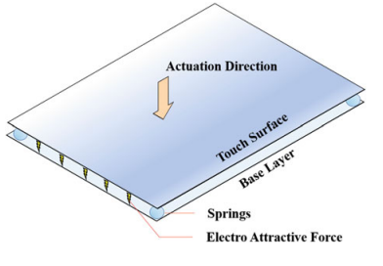

Figure 2: Surface actuation solution from Pacinian Corp.

### Electroactive Polymer (EAP) Actuator

Electroactive polymers (EAP) use electric signal-induced mechanical displacement to provide haptic feedback. According to their activation method, EAP actuators' working mechanisms can be split into ionic- and electronic-based architectures. High haptic resolution displays have been made using EAP techniques. Each actuator in the display may be manipulated separately to change the display's height, transmittance, and flexibility. Because of its great effectiveness in providing displacements with high spatial precision, EAP techniques are also used for braille reading. It should be mentioned that EAP technology is still in development, and various challenges remain unresolved. EAP materials are sensitive to humidity, necessitating the implementation of a water-impermeable surface. Long-term use results in a heavy electrolyte loss phenomenon, which influences surface conductivity. A heat-resistant design is preferred to facilitate operation at higher voltages without destroying the material's internal structure.

Figure 3: Generation of visual and palpable information by the ‘‘artificial skin’’. a) When the phase transition temperature is exceeded, the hydrogel immediately changes its color from transparent to opaque. The ‘‘artificial skin’’ displays monochrome visual information. b) After finishing the shrinking process, the skin maps the sharp outlines of a dolphin. The length of the dolphin from mouth to tail is 14.5 mm. c) The hydrogel actuator array maps the dolphin with sharp contours and single-pixel accuracy. d) In order to improve the palpation of edges and outlines, a knob is placed on top of each actuator.

ORIGIN “High haptic resolution displays” and figure: <https://onlinelibrary.wiley.com/doi/10.1002/adma.200802737>

### Capacitive Electrosensory Interface

In 2009, Senseg Oy presented E sense, the first capacitive electrosensory interface (CEI) method. It uses a short-distance capacitive coupling mechanism to communicate conventional indentation to the skin.

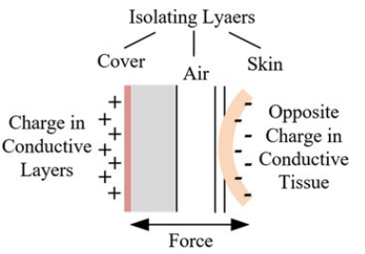

Figure 4: Working principle of the E-sense when the weakly conductive layer is embedded under the surface of the touch device

The conductive layer is charged during operation, and the coupling mechanism causes the opposing charges to accumulate on the finger that contacts the screen surface. These opposing charges will be attracted to each other by the Coulomb effect, producing a mechanical force. The vibrational amplitude and frequency can be modified to suit a variety of applications by modifying the polarity and quantity of the charges on the conductive layer and adjusting the frequency of the driving voltage waveform. CEI has some benefits, the vibration feedback's frequency, strength, and roughness can all be adjusted independently. Also, the finger can hang in the air and communicate both pressure and touch using the principle of short-distance capacitive coupling. However, the effective vibration range is quite small. Also, under sweating conditions, the vibration performance is considerably reduced.

## Functional Electrical Stimulation

The study on bioelectrical stimulation published in Shuo Gao's book shows that the bioelectrical stimulation technique can improve the performance of the interaction between man and machine. Indeed, the haptic feedback results in the activation of the muscles by the electrical pulses. In addition, the biological study that benefits the development of functional electrical stimulation shows the composition of the sensory receptors of human fingers. In fact, the so-called Axon receptors are of the fast-adapting type, the slow adapting type I and the Pacinian corpuscle.

These different cells have well-defined functions. The fast-adapting axons are the closest to the superficial skin and the slow-adapting type I is the second closest, while the Pacinian corpuscle is the deepest. Indeed, the axons are stimulated from the inside and outside as the potential inside the axon is relatively stable, the activation force is directly associated with the potential outside. In addition, this technology uses electrodes to inject current through the skin, and at the same time generate pressure and vibration sensations to achieve haptic feedback.

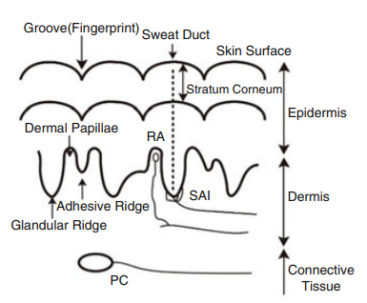

## Ultrasonic haptic technologies in the air

In the article by M.Marchal 2020, it is demonstrated that focused ultrasound haptics can provide the sensation of interacting with objects of different stiffness. Indeed, focused airborne ultrasound (very high intensity and focused mechanical wave) is the most advanced technology to provide airborne haptics. In this paper, the experiment was performed with an Ultrahaptics STRATOS platform, which is a commercially focused ultrasound array. An HTC Vive tracker was attached to the participants' dominant wrist to track their hand movement, and a virtual hand avatar mimicked this movement in the virtual environment. In fact, the aim was to demonstrate the contact ultrasound method of control. This can detect the stiffness of a surface and scan large surface defects such as delamination.

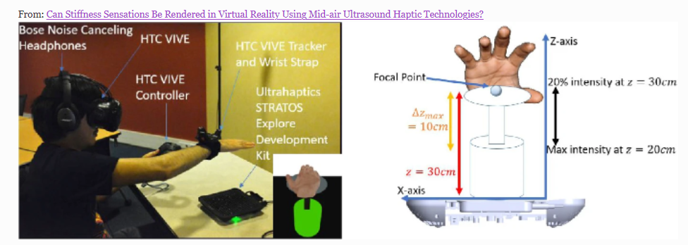

## Thermal variations

In the article from Techxplore written by Steve Kuhlman on 3 March 2022, the research team explains that a feeling provided by friction during a contact with a touchscreen can be modified by changing locally the temperature. So, they will be able to reproduce some texture like “the skin of a snake” or “fabric of clothes”. They explain that there is a unique couple of mechanical and thermal sensations associated with a specific texture. The application domains are very varied and are very interesting for the metaverse. They didn’t give any details about how it works because the research is just beginning, and it remains a lot of difficulties and things to discover. For example, the miniaturization and the integration of the touchscreen will be a great challenge!

## Mechanical tools and temperature

As we have said so well in our paper, haptic feedback allows us to simulate the sensations of touch. These sensations are perceptible in interactive experiences such as virtual reality, for example, but also in other experiences such as increased virtual reality or the metaverse, which is a combination of the two.

Most of the experiments that have been carried out highlight the use of mechanisms that can simulate this sensation of touch. Thanks to different sensors, haptic gloves, for example, can offer a sensation of finger resistance on an object. \cite{hapticglove}

Micro-vibrations can simulate different textures at the fingertips \cite{hapticaptor}. These mechanisms greatly increase immersion in virtual reality and are also used on full suits \cite{hapticsuit}.

The experiment in the paper Smart Tactile Gloves for Haptic Interaction, Communication, and Rehabilitation shows that a multimodal sensing and feedback glove is developed with flexible, stretchable, lightweight, and compact sensor and heater sheets made by direct ink writing of a liquid metal, eutectic gallium-indium. In the sensor sheet, ten sensors and three vibrators are integrated to measure finger movements and provide vibro-haptic feedback. The other heated sheet provides accurate and fast thermo-haptic sensation via pattern-based feedback control, even under stretched conditions. The multi-modal sensing and feedback glove allows users to feel the contact state and distinguish materials \cite{hapticglove1}. The most interesting product in that document are the smart gloves based on gesture and touch. These gloves are very useful in many different areas, such as telemanipulation, medical/military training, virtual collaborative product design, smart manufacturing, gaming, entertainment, and product advertising. This kind of glove used a resistive fabric-based material and doesn’t need any actuator material. It need a supply power of 227mW and is able to use Wi-Fi as wireless communication protocols\cite{hapticglove1}.

Figure : Smart gloves combining gesture and touch. a) Wearable hand rehabilitation system with soft gloves: this glove recognizes touch at certain points on the fingers and palm, as well as measuring finger bending angles for gesture recognition. b) Pressure and flex sensors are used in this glove to define fine hand movement.

Those gloves were tested and used for badminton, but they could also be used in other VR/AR applications. The glove does a good job of conveying the feel of the ball bouncing off the badminton racket. It is said to easy to wear. However, a little difficulty to put it on and is described as fragile, the sudden movements are to be avoided\cite{hapticglove1}.

They performed the experiment on the haptic suit. Indeed, thanks to the sensors integrated in the suit, the muscles are stimulated and produce the sensation of touch on the body \cite{hapticexperience}.

Its haptic system allows motion capture, temperature control and biometric monitoring. Electrostimulation is used to simulate heat and cold sensations on the body.

In fact, the suit contains 68 electrical channels to enable the wearer to feel all the sensations of touch. It is these channels that allow the wearer to feel all the sensations of touch, precisely localised on the body. \cite{hapticexperience}

In conclusion, this combination allows realistic sensations to be reproduced according to what is happening in the digital world. It allows users to feel every interaction in the virtual environment by touch. It would therefore be better to combine the haptic suit with the haptic glove.

@article {hapticglove,

author = "Oliver Ozioko; Ravinder S. Dahiya",

title = "Experiences of using Shockwaves for Haptic Sensations",

year = "2021"

}

@article {hapticaptor,

author = "Jose Dionisio; Volker Henrich; Udo Jakob; Alexander Rettig",

title = " The virtual touch: Haptic interfaces in virtual environments ",

year = "1997"

}

@article {hapticsuit,

author = "Hiroaki Yano; Tetsuro Ogi; Michitaka Hirose",

title = " Development of Haptic Suit for Whole Human Body Using Vibrators ",

year = "1998"

}

@article {hapticglove1,

author = "Mark Paterson",

title = " The Senses of Touch: Haptics, Affects and Technologies,

year = "2020"

}

@article {hapticexperience,

author = "Hiroaki Yano; Tetsuro Ogi; Michitaka Hirose",

title = " Development of Haptic Suit for Whole Human Body Using Vibrators ",

year = "1998"

}

PARLER DES TECHNO HAPTIQUE DANS LES NEURONES (dans la v2)

EXPERIENCE

## Simulate haptic sensation using sound

### An additional feeling

In order to reproduce the sensation of touch accurately, it must be accompanied by a sound after each action. To demonstrate the effectiveness of realism of the sound, the document “Audio-haptic physically-based simulation of walking on different grounds” puts forward that “In the development of multimodal environments such as games and virtual reality installations, walking sounds are often used to produce physicality and a sense of action, with the overall goal of heightening the realism of a character or person.” \cite{soundAndHapic}. The authors of this paper conducted the experiment using shoes with a pressure sensor and two integrated vibrations-based actuators in each of them. The actuators were fixed under the toe and the heel to enable proper vibration transfer inside the soles.

Figure 5 : System (one shoe shown). Left: recoil-type actuation from Tactile Labs Inc. The moving parts are protected by an alumimum enclosure able

The actuators were all powered by the same signal, but they could be engaged separately to highlight front or rear activation, strike a balance, or achieve other effects like modulating various back-front signals during heel-toe movements. Algorithms simulating the sounds of people walking on different surfaces were used. So, they were able to simulate a real-time footfall synthesizer that provides audio and haptic feedback. “The developed system is ready to be integrated in computer games and interactive installations where a user can navigate.” \cite{soundAndHapic}.

### Shockwaves for Haptic Sensations

The use of other means of providing haptic sensations was largely inspired by Yanagida's air gun, which led to the exploration of loudspeaker-based air cannons\cite{soundAndHapic2}. In the paper “Experiences of using Shockwaves for Haptic Sensations”, experiments have been carried out using the iCone. The iCone is a spherical screen about 7 metres in diameter and has a field of view of 210 degrees, with slightly sloping walls (7 degrees towards the back), giving it a conical shape. The iCone has 16 speakers that where to be placed in a spherical setup, in a top and bottom ring. The sound will produce a vibration through the body and give a sensation of touch. The result were not as good as expected, in fact, the document state the following sentence : “Users especially report on the effects of the sound floor – acoustic effects like a heartbeat in a medical demo can be clearly experienced via vibration.”, but : “Most users do not directly realize the haptic effects of the system”. The vibrations of the floor, which are generated by both the subwoofers and the Paraseats, jolt the user's body, causing mild but distinct sensations in the stomach and chest. Most haptic effects appear to be caused by vibrations sent from the feet through the user's bone structure. Some effects cannot be reproduced, such as the blast effect. Because this requires a sudden increase in volume from 1 to 80 decibels and can cause health problems to the user such as drowsiness or stomach problems\cite{ISO-vibration}. Finally, “The validity of the vibrations therefore mainly seems to be to enhance a sound system by making sound effects tactile”. The tactility can be used to simulate the effects of collisions, such as colliding with a wall. The vibration also appears to provide motion clues. The most likely reason for this effect is that vibrations beyond a particular level (90dB) cause motion feelings in a portion of the inner ear\cite{soundAndHapic2}. The main problems with that solution are its size, its inability to produce certain effects that may not be harmful to health, and unexpected motion sensations because of vibrations in the inner ear.

@article {soundAndHapic,

author = "Luca Turchet; Rolf Nordahl; Stefania Serafin; Amir Berrezag; Smilen Dimitrov; Vincent Hayward",

title = "Audio-haptic physically-based simulation of walking on different grounds",

year = "2010"

}

@article {soundAndHapic2,

author = "Ernst Kruijff; Aeldrik Pander",

title = "Experiences of using Shockwaves for Haptic Sensations",

year = "2005"

}

@article {ISO-vibration,

author = "ISO",

title = "Mechanical vibration and shock — Evaluation of human exposure to whole-body vibrations",

year = "1997"

}

Simulation of haptic sensation by stimulating neural activity

Haptic simulation can also be recreated by stimulating neural networks. In the document “An artificial sensory neuron with visual-haptic fusion”, they state that “biological systems always outshine their electronic counterparts due to their sophisticated sensorimotor skills”, also, they claim that biological systems have a “superior fault tolerance and power efficiency are inherent in the adaptive, plastic, and event-driven network of sensory neurons.”. Knowing that, simulating biological processes at the level of sensory neurons would enable biological perceptual skills to be realized \cite{neural-haptic}.

To experiment the sensations of touch and vision, a bimodal artificial sensory neuron (BASE) has been developed. This neuron is based on a hybrid ionic/electronic neuromorphic electronics. This BASE unit consists of four core components: resistive pressure sensor, perovskite-based photodetector, hydrogel-based ionic cable, and a synaptic transistor.

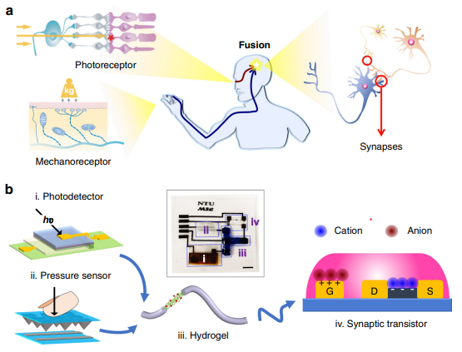

Figure 6 : A bimodal artificial sensory neuron with visual-haptic fusion. a) The visual-haptic fusion by biological neural network. b) The BASE patch for visual/haptic fusion. Sub-figures i to iv: photodetector, pressure sensor, hydrogel, and synaptic transistor, respectively. Inset: a photograph of the BASE patch. The scale bar is 5 mm.

External haptic and optical cues are converted into electrical signals by the photodetector and pressure sensor, which are receptors in the retina and skin. The electrical signals from the two sensors are then sent to the synaptic transistors via the ionic cable, where they are combined and converted into a transient channel current. Bimodal stimuli are used to offer multidimensional spatial information, allowing a biohybrid neuromuscular junction or a robotic hand to be controlled, simulating the 'perception for action' process\cite{neural-haptic}.

The hybrid neural circuits are essentially characterised by the visual channel and the haptic channel. The visual channel comprises a perovskite-based photodetector and represents the photoreceptors of the human retina. These photoreceptors are stable in the environment for reliable and repeatable photodetection. The haptic channel is composed of a pressure sensor that incorporates microstructures in the top layer of poly-coating. Experimental results show that when pressure is applied to the top layer, it forms a resistive path with the electrodes of the bottom layer. Increasing the pressure increases the contact area and this has an inverse effect on the resistance which decreases. The information from the two artificial sensory channels is carried by the ionic cables which perform the function of ionic transmission.

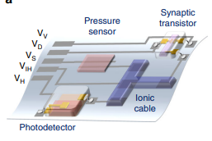

Furthermore, the development of the ionic hybrid, mimicking the supermodal sensory fusion in the sensory nervous system, combines optical and pressure stimuli to generate biological excitatory postsynaptic currents through the synaptic transistor. The time-dependent bimodal information carried by this current is like neural behaviour. This signal is used to innervate skeletal myotomes and provide information for the movement of robotic hands for example. This mimics the control of movement by using bimodal sensory signals at the unimodal cellular level\cite{neural-haptic}.

The bimodal artificial sensory neuron (BASE) is characterised by a sensory modality based on pressure and light, and it uses the 15mm Myotube as an actuator. In addition, the size of its action is 5 µm and its recognition mode is multi-transparency with dendritic integration constituting synapse emulation\cite{neural-haptic}.

@article {neural-haptic,

author = "Changjin Wan; Pingqiang Cai; Xintong Guo; Ming Wang; Naoji Matsuhisa; Le Yang; Zhisheng; Yifei Luo; Xian Jun Loh; Xiaodong Chen",

title = "An artificial sensory neuron with visual-haptic fusion",

year = "2020"

}

They performed the experiment on the haptic suit. Indeed, thanks to the sensors integrated in the suit, the muscles are stimulated and produce the sensation of touch on the body\cite{hapticexperience}.

Its haptic system allows motion capture, temperature control and biometric monitoring. Electrostimulation is used to simulate heat and cold sensations on the body.

In fact, the suit contains 68 electrical channels to enable the wearer to feel all the sensations of touch. It is these channels that allow the wearer to feel all the sensations of touch, precisely localized on the body\cite{hapticexperience}.

Technologies using neuromuscular stimulation are haptic suits. Using built-in sensor, the suit stimulates the muscles and produces the feeling of touch on the body\cite{hapticexperience}. That haptic system allows motion capture, temperature control and biometric monitoring. Electrostimulation is used to simulate heat and cold sensations on the body. Here is an example with the characteristics with an existing technology : the teslasuit\cite{teslasuit}.

@article {teslasuit,

author = "Teslasuit",

title = "TESLASUIT DK1 SPECIFICATION",

year = "2021"

}

# CONCLUSION